VOLUME 3
ROBOT OPERATING SYSTEM (ROS 2)
Architecture | Distributions | Fundamentals | Communication | Robot Description | Gazebo Simulation
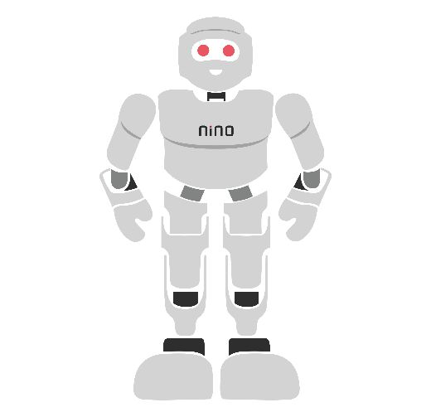

Module Overview
A modern robot runs many programs at the same time: one reads the laser scanner, one estimates where the robot is, one plans a path, one drives the motors and one shows everything on a screen. These programs must exchange data reliably, many times per second. Writing all of this from zero for every robot would take years. The Robot Operating System (ROS) is a free, open-source framework that provides the plumbing, tools and ready-made packages so that engineers can focus on what makes their robot special.
This module teaches ROS 2, the current generation, from the ground up: its architecture, how releases (distributions) work and which one to install, the fundamental building blocks (nodes, packages, workspaces, launch files), the four ways nodes communicate (topics, services, actions and parameters), how a robot’s shape is described (URDF, xacro and TF), and finally how to simulate a complete mobile robot with a laser scanner in Gazebo. Every lab uses free software. Taught end-to-end, the module is designed to fill approximately 30–34 hours of instruction and practice.
# | Topic | Hands-on Focus
1 | Introduction to ROS and ROS Architecture | Explore the ROS 2 layer model
2 | ROS Distributions and Installation | Install ROS 2 Jazzy on Ubuntu 24.04
3 | ROS Fundamentals | Lab 1: Exploring ROS 2 with turtlesim
4 | ROS Communication | Lab 2: Publisher, subscriber and service in Python
5 | Robot Description (URDF, xacro, TF) | Lab 3: Describe a mobile robot
6 | Gazebo Simulation of a Mobile Robot | Lab 3: Drive it in Gazebo and RViz
7–8 | Lab Exercises and Mini-Project | Autonomous obstacle-avoiding robot
9–10 | Troubleshooting, Assessment and Revision | Formula sheet, questions, rubric

Learning Outcomes
By the end of this module, learners will be able to:
- Explain what ROS is, why it is used, the ROS 2 layer architecture and the main differences from ROS 1.
- Select a suitable ROS 2 distribution and matching Ubuntu and Gazebo versions, and install and configure ROS 2.
- Create, build and run ROS 2 Python packages in a colcon workspace, and use the ros2 command-line tools.
- Choose between topics, services, actions and parameters, and implement them with rclpy, including QoS settings.
- Write a URDF/xacro description of a mobile robot with correct links, joints, inertia and TF frames.
- Simulate a differential-drive robot with a lidar in Gazebo, connect it to ROS 2 with ros_gz_bridge and view it in RViz.
- Build a node that reads sensor data and commands the robot autonomously, and troubleshoot common ROS problems.
Hardware and Software Required
Item | Purpose | Notes
PC: 4-core CPU, 8 GB RAM (16 GB recommended), 30 GB free disk | Run ROS 2 and Gazebo | A dedicated GPU makes Gazebo smoother
Ubuntu 24.04 LTS (native, dual-boot or virtual machine) | Officially supported OS for ROS 2 Jazzy | Windows: WSL2 with Ubuntu 24.04
ROS 2 Jazzy Jalisco (desktop) + ros-dev-tools | ROS core, RViz2, rqt, turtlesim, colcon | Free, Apache 2.0 licence
Gazebo Harmonic + ros_gz packages | Robot simulation and bridge to ROS 2 | Installed with ros-jazzy-ros-gz
VS Code (or any editor), Git, terminal | Write and manage code | Free
Optional: TurtleBot 4 / TurtleBot3 or a Raspberry Pi robot | Run the same nodes on real hardware | Not required for any lab

Before you start
ROS releases change every year. This module uses the long-term-support combination Ubuntu 24.04 + ROS 2 Jazzy + Gazebo Harmonic, which has the widest package and tutorial support. Always check docs.ros.org for the current recommended versions and installation steps before installing.

1. Introduction to ROS and ROS Architecture

1.1 What Is ROS?
Despite its name, ROS is not an operating system like Windows or Linux. It is a middleware framework that runs on top of an operating system (mainly Ubuntu Linux). It provides three things: (1) a communication system that lets many small programs exchange data; (2) tools for building, running, visualising, recording and debugging robot software; and (3) a huge ecosystem of open-source packages — drivers, navigation, arm motion planning, simulation and more — shared by thousands of companies, universities and hobbyists.
A simple analogy: if a robot is a company, each ROS program (node) is an employee with one job. ROS is the company’s internal postal and telephone system, its rulebook for message formats, and its shared library of standard procedures.

1.2 Why Use ROS?
- Reuse: use proven packages (e.g. Nav2 for navigation, MoveIt 2 for robot arms) instead of rewriting them.
- Modularity: each node does one job and can be tested, replaced or restarted on its own.
- Language freedom: nodes in Python and C++ talk to each other seamlessly.
- Distribution: nodes can run on different computers in the same network without code changes.
- Tools and community: visualisation, logging, simulation and a large community make learning and debugging faster.

1.3 From ROS 1 to ROS 2
ROS began in 2007 and became the standard for research robots. ROS 1 relied on a central program, the master (roscore), which every node had to contact to find others; it had no built-in security and weak real-time support. ROS 2 was redesigned around the industrial DDS (Data Distribution Service) standard: nodes find each other automatically, there is no single point of failure, and it supports quality-of-service settings, security, real-time systems, Windows and macOS. The last ROS 1 release, Noetic, reached end of life in May 2025, so all new projects should use ROS 2.
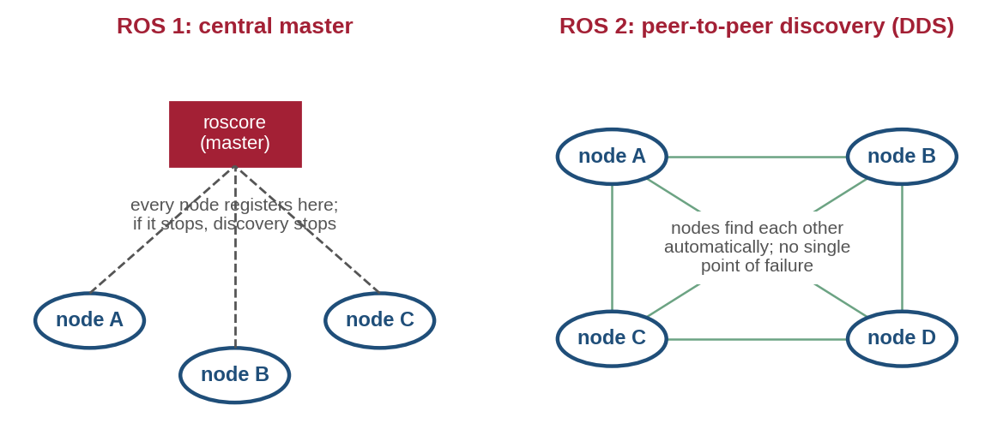
Figure 1.1: Discovery in ROS 1 (all nodes depend on a central master) and ROS 2 (nodes discover each other peer-to-peer through DDS).
Feature | ROS 1 | ROS 2
Discovery | Central master (roscore) | Automatic, peer-to-peer (DDS)
Communication layer | Custom TCPROS/UDPROS | DDS or other middleware via rmw
Quality of service | Basic | Configurable (reliability, durability, history…)
Security, real time, multi-robot | Limited | Built-in support
Operating systems | Linux | Linux, Windows, macOS
Build tool / Python API | catkin / rospy | colcon / rclpy
Status | Ended (Noetic EOL May 2025) | Actively developed

1.4 The ROS 2 Architecture
ROS 2 is built in layers (Figure 1.2). You write application nodes using a client library — rclpy for Python or rclcpp for C++. Both are thin wrappers around rcl, a common core written in C, so behaviour is identical in both languages. rcl talks to the network through the rmw (ROS middleware) interface, which hides the actual middleware implementation — by default eProsima Fast DDS, with alternatives such as Eclipse Cyclone DDS or Zenoh. Because of this layering, you can change the middleware without touching your code.
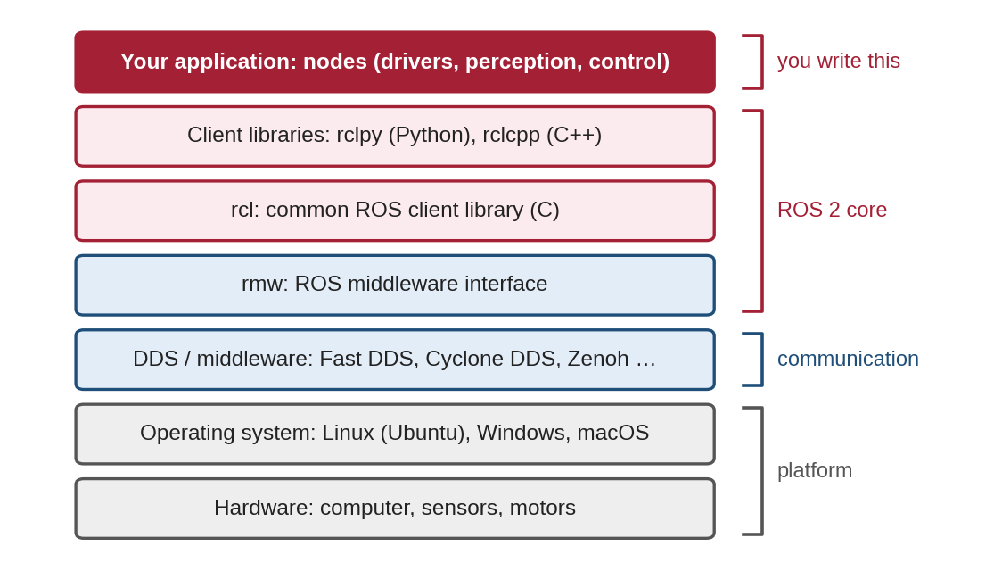
Figure 1.2: Layered architecture of ROS 2 from user application down to the hardware.

1.5 The ROS 2 Ecosystem
Around this core sits a large ecosystem: the ros2 command-line tool, RViz2 for 3D visualisation, rqt graphical plug-ins (node graph, live plots, logs), ros2 bag for recording and replaying data, the Gazebo simulator (Section 6), Nav2 for autonomous navigation, MoveIt 2 for robot-arm motion planning and ros2_control for motor controllers.

1.6 Common Mistakes to Avoid
- Following a ROS 1 tutorial (rospy, catkin, roscore) for a ROS 2 system — the commands and APIs are different.
- Thinking ROS replaces Linux — ROS needs an operating system underneath.
- Putting everything in one giant node — split work into small nodes with clear jobs.

2. ROS Distributions and Installation

2.1 What Is a Distribution?
A ROS distribution (distro) is a versioned set of ROS packages that are tested to work together, similar to a version of Ubuntu. Distros are named alphabetically with an adjective and a turtle species (Humble Hawksbill, Iron Irwini, Jazzy Jalisco, Kilted Kaiju, Lyrical Luth…). A new ROS 2 distro is released every May 23 (World Turtle Day). Releases in even years are LTS (long-term support) and are maintained for 5 years; releases in odd years are maintained for about 1.5 years. Rolling Ridley is a continuously updated development distro and is not meant for students or products.
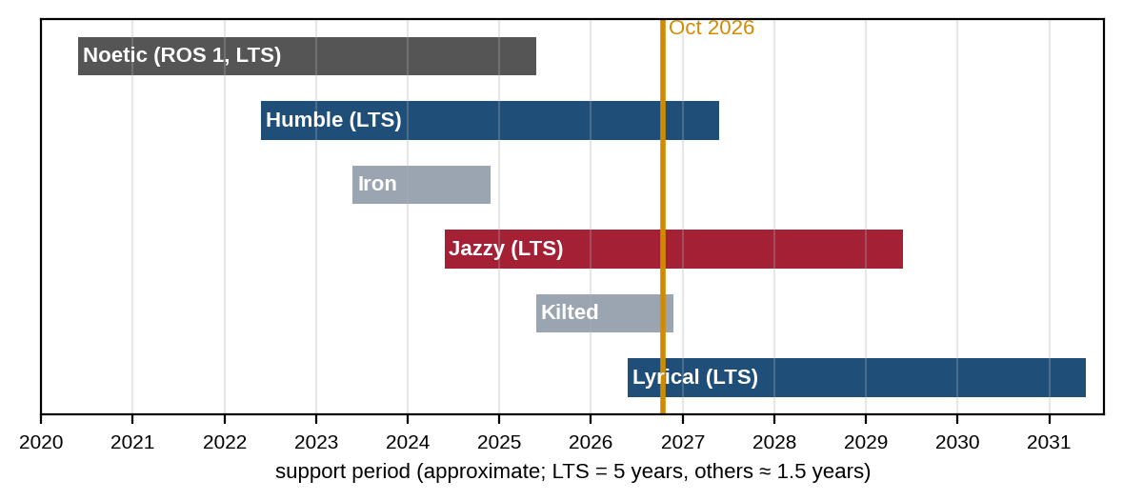
Figure 2.1: Approximate support periods of recent ROS distributions (LTS releases in colour).
Distro | Released | End of life | Ubuntu | Gazebo pairing
Humble Hawksbill (LTS) | May 2022 | May 2027 | 22.04 | Fortress
Iron Irwini | May 2023 | Nov 2024 (ended) | 22.04 | Fortress
Jazzy Jalisco (LTS) — used here | May 2024 | May 2029 | 24.04 | Harmonic
Kilted Kaiju | May 2025 | ≈ Nov 2026 | 24.04 | Ionic
Lyrical Luth (LTS) | May 2026 | ≈ May 2031 | 26.04 | Jetty

Which one should I use? Each distro supports one main Ubuntu version, and each pairs with a recommended Gazebo version. Pick an LTS distro that matches your Ubuntu version and that the packages you need already support. This module uses Jazzy on Ubuntu 24.04 with Gazebo Harmonic, a mature LTS combination supported until 2029. If you already run Ubuntu 22.04, Humble with Gazebo Fortress also works, but Gazebo plug-in names differ slightly. Dates for the newest distros are approximate: confirm them on the official releases page (REP 2000).

2.2 Installing ROS 2 Jazzy on Ubuntu 24.04
Run these commands in a terminal. They set a UTF-8 locale, enable the ROS package repository, then install ROS, the developer tools and the Gazebo integration. The repository set-up step has changed in the past, so compare it with the current guide at docs.ros.org before running it.
# 1. locale and Ubuntu "universe" repository
sudo apt update && sudo apt install -y locales software-properties-common curl
sudo locale-gen en_US en_US.UTF-8 && export LANG=en_US.UTF-8
sudo add-apt-repository -y universe

# 2. add the ROS 2 apt source (package provided by the ROS infrastructure team)
export ROS_APT_SOURCE_VERSION=$(curl -s https://api.github.com/repos/ros-infrastructure/ros-apt-source/releases/latest | grep -F "tag_name" | awk -F\" '{print $4}')
curl -L -o /tmp/ros2-apt-source.deb "https://github.com/ros-infrastructure/ros-apt-source/releases/download/${ROS_APT_SOURCE_VERSION}/ros2-apt-source_${ROS_APT_SOURCE_VERSION}.$(. /etc/os-release && echo $VERSION_CODENAME)_all.deb"
sudo dpkg -i /tmp/ros2-apt-source.deb

# 3. install ROS 2, developer tools, Gazebo bridge and extras used in this module
sudo apt update && sudo apt upgrade -y
sudo apt install -y ros-jazzy-desktop ros-dev-tools ros-jazzy-ros-gz \
ros-jazzy-xacro ros-jazzy-teleop-twist-keyboard liburdfdom-tools

# 4. load ROS in every new terminal
echo "source /opt/ros/jazzy/setup.bash" >> ~/.bashrc && source ~/.bashrc
ros2 doctor --report | head -n 20 # quick health check

Windows users can install Ubuntu 24.04 in WSL2 (Windows Subsystem for Linux), which supports graphical apps such as RViz and Gazebo, and then follow the same steps. macOS users should use an Ubuntu virtual machine. Docker images (e.g. osrf/ros:jazzy-desktop) are another option for advanced users.

2.3 The ROS Environment
ROS works through environment variables. Running source /opt/ros/jazzy/setup.bash tells the terminal where ROS is installed; without it, the ros2 command is not found. Your own workspace adds a second layer on top (an overlay, Section 3.3). Two other useful variables:
- ROS_DOMAIN_ID (default 0): nodes only see other nodes with the same ID. In a classroom where all PCs share one network, give each student a different ID (e.g. export ROS_DOMAIN_ID=12, using values from 0 to 101) so their robots do not interfere.
- ROS_AUTOMATIC_DISCOVERY_RANGE=LOCALHOST: keeps discovery inside your own computer — useful on shared Wi-Fi.

2.4 Common Mistakes to Avoid
- Installing a distro on the wrong Ubuntu version (e.g. Jazzy on 22.04) — packages will not be found.
- Mixing two distros in one terminal (sourcing both Humble and Jazzy).
- Forgetting to source the setup file in a new terminal: "ros2: command not found".
- Students on the same network seeing each other’s topics because they all use ROS_DOMAIN_ID 0.

3. ROS Fundamentals

3.1 Nodes
A node is a single running program that does one well-defined job, such as reading a lidar or driving the wheels. Nodes have unique names (e.g. /turtlesim) and communicate only through ROS. A node written with rclpy creates its publishers, subscribers, timers and services in its constructor and then calls rclpy.spin(), which waits for events and runs the matching callback functions.

3.2 Packages and Workspaces
Code is organised into packages. A package is a folder with a manifest (package.xml: name, version, licence, dependencies) and build instructions. Python packages use the ament_python build type (with setup.py); C++ packages use ament_cmake (with CMakeLists.txt). Packages live in the src folder of a workspace (Figure 3.1).
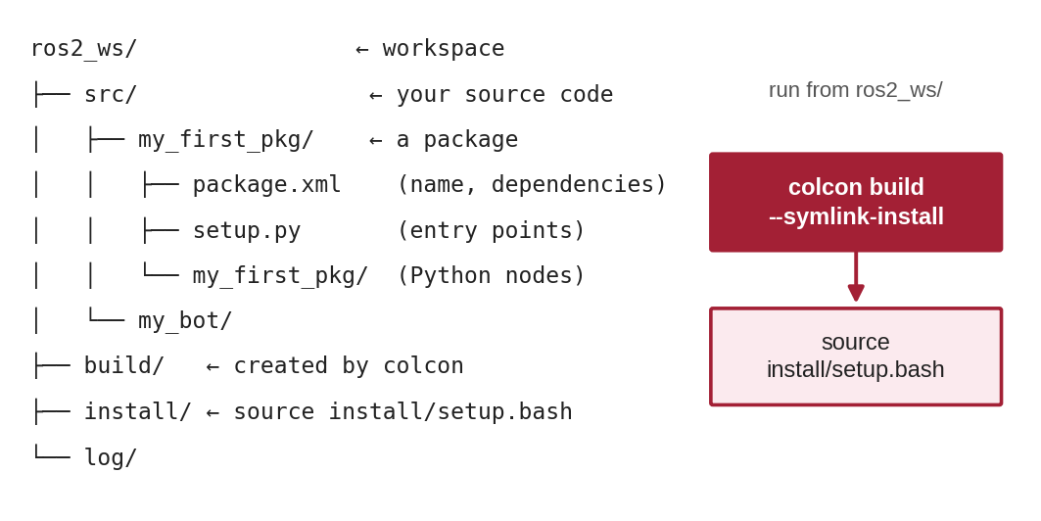
Figure 3.1: Structure of a ROS 2 workspace before and after building with colcon.

3.3 Building with colcon
colcon is the ROS 2 build tool. From the workspace root, colcon build --symlink-install builds every package in src and creates the build, install and log folders. The --symlink-install option links Python files instead of copying them, so edits take effect without rebuilding (new files and changes to setup.py still need a rebuild). After building, run source install/setup.bash: this overlay adds your packages on top of the ROS installation (the underlay). Build and source from the workspace root, in a terminal that has already sourced ROS.

3.4 Interfaces: Messages, Services and Actions
Nodes exchange data in strictly typed structures called interfaces, defined in simple text files: .msg for topic messages, .srv for service request/response pairs and .action for actions. You can inspect any interface with ros2 interface show <type>. Common types:
Interface type | Contents | Typical use
std_msgs/msg/String | string data | Simple text messages (learning)
geometry_msgs/msg/Twist | linear (x, y, z) and angular (x, y, z) velocity | Velocity commands, /cmd_vel
sensor_msgs/msg/LaserScan | angle_min, angle_increment, ranges[] … | 2D lidar scans, /scan
nav_msgs/msg/Odometry | pose and twist with covariance | Estimated robot motion, /odom
sensor_msgs/msg/Image | width, height, encoding, data[] | Camera images
example_interfaces/srv/AddTwoInts | request: a, b; response: sum | Learning services

3.5 Parameters and Launch Files
A parameter is a named setting that belongs to a node, such as a speed limit or a sensor port. Parameters can be set at start-up, changed at run time with ros2 param set, or loaded from YAML files, so the same code can be reused with different settings. A launch file (usually written in Python) starts several nodes at once with their parameters, remappings and other launch files — a robot may need 10–30 nodes, and starting them one by one by hand is impractical. You will write one in Lab 3.

3.6 Command-Line and Graphical Tools
Command | What it does
ros2 run <pkg> <executable> | Start one node
ros2 launch <pkg> <file.launch.py> | Start a launch file
ros2 node list / info <node> | List nodes / show a node’s connections
ros2 topic list / echo / hz / info / pub | List topics, print messages, measure rate, show types, publish by hand
ros2 service list / call | List services / call one
ros2 action list / send_goal | List actions / send a goal
ros2 param list / get / set | Inspect and change parameters
ros2 interface show <type> | Show the fields of a message, service or action
ros2 bag record / play | Record and replay topics
rqt_graph · rviz2 | Draw the node graph · 3D visualisation

3.7 Common Mistakes to Avoid
- Running colcon build inside src instead of the workspace root.
- Forgetting to source install/setup.bash after building: "Package not found".
- Adding a new node file but not registering it in setup.py entry_points.
- Missing dependencies in package.xml — the code works on your PC but fails elsewhere.

4. ROS Communication

4.1 The Computation Graph
All running nodes and the connections between them form the computation graph. Figure 4.1 shows the graph of the turtlesim example used in Lab 1: a keyboard node publishes velocity commands, the simulator subscribes to them and publishes the turtle’s pose, which any other node can read.
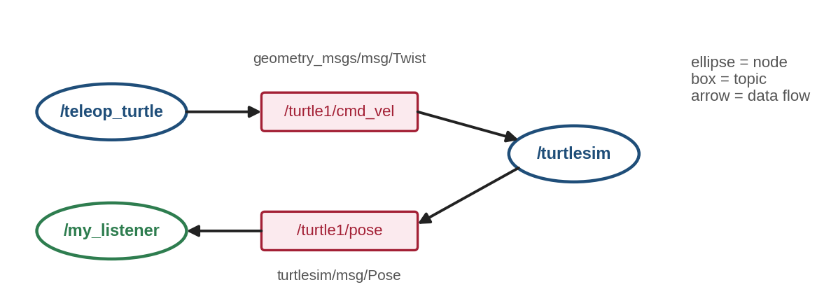
Figure 4.1: Computation graph of turtlesim: nodes (ellipses) connected through topics (boxes).

4.2 The Four Communication Methods
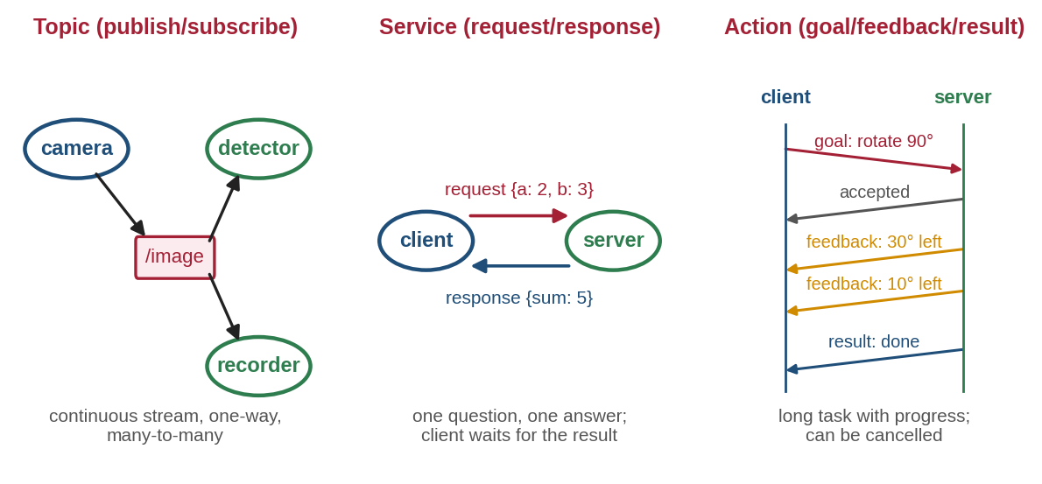
Figure 4.2: Topics, services and actions: three patterns for different kinds of exchange.
Topics (publish/subscribe). A publisher sends messages on a named topic; any number of subscribers receive them. Publishers do not know who is listening, so nodes stay independent. Topics are used for continuous data streams: sensor readings, velocity commands, robot state.
Services (request/response). A client sends a request and the server returns one response, like calling a function on another node. Services suit quick, occasional operations: "reset the map", "spawn a turtle", "add two numbers". They should finish quickly; long jobs block the client.
Actions (goal/feedback/result). For long tasks — "drive to the kitchen", "rotate 90°" — a client sends a goal, receives regular feedback while the server works, and finally a result. The client can cancel the goal at any time. Actions are built from topics and services internally.
Parameters store node settings (Section 3.5) and are read or changed through built-in services.
Need | Use | Example
Continuous data, many receivers | Topic | /scan at 10 Hz, /cmd_vel
Quick question with an answer | Service | /spawn, /add_two_ints
Long task with progress and cancel | Action | /turtle1/rotate_absolute, Nav2 navigate_to_pose
Configuration value | Parameter | max_speed, background_r

4.3 Quality of Service (QoS)
Because ROS 2 runs on DDS, every publisher and subscriber has QoS settings that control delivery. The most important ones are:
Policy | Options | Meaning
Reliability | RELIABLE / BEST_EFFORT | Re-send lost messages, or drop them for low delay (sensor data)
History + depth | KEEP_LAST(n) / KEEP_ALL | How many messages to queue (the '10' in create_publisher)
Durability | VOLATILE / TRANSIENT_LOCAL | Whether late subscribers get the last message (used for /robot_description)
Deadline, lifespan, liveliness | time values | Detect late data, drop old data, detect dead publishers

Publisher and subscriber QoS must be compatible: a RELIABLE subscriber will not receive data from a BEST_EFFORT publisher, and no error appears in your code — the messages simply never arrive. ros2 topic info -v <topic> shows the QoS of every endpoint.

4.4 Discovery and Data Rates
When a node starts, DDS announces it on the network and matches publishers and subscribers with the same topic name, type and compatible QoS — no master is needed. Data volume matters on Wi-Fi. Worked example 4.1. A 360-sample LaserScan stores ranges and intensities as 4-byte floats: 2 × 360 × 4 = 2,880 bytes per scan; at 10 Hz that is about 29 kB/s — easy. A 640 × 480 RGB camera image is 640 × 480 × 3 = 921,600 bytes; at 30 Hz that is about 27.6 MB/s — too much for most Wi-Fi links, which is why images are compressed or processed on the robot.

4.5 Common Mistakes to Avoid
- Topic name or type mismatch (e.g. cmd_vel vs /robot/cmd_vel) — check with ros2 topic info.
- Using a service for a long task, freezing the calling node.
- Blocking inside a callback with time.sleep(), which stops all other callbacks of that node.
- Ignoring QoS incompatibility between sensor publishers (BEST_EFFORT) and RELIABLE subscribers.

5. Robot Description: URDF, xacro and TF

5.1 Why Describe the Robot?
Many ROS tools need to know the robot’s shape: RViz draws it, Gazebo simulates its physics, navigation needs its size and the position of each sensor. The Unified Robot Description Format (URDF) is an XML file that describes the robot as a tree of links (rigid parts) connected by joints — the same idea as the kinematic chains of the earlier modules.

5.2 Links and Joints
Each link can have three parts: <visual> (what it looks like), <collision> (a simple shape used for contact; often the same as the visual) and <inertial> (mass and inertia, required by Gazebo). Each joint names a parent and a child link, the child’s position (<origin xyz rpy>, metres and radians), and a motion axis. ROS uses the right-handed convention of REP 103: x forward, y left, z up.
Joint type | Motion | Example on our robot
fixed | No motion | base_link → lidar_link, caster_link
continuous | Rotation without limits | Wheels
revolute | Rotation between limits | Robot arm joint, steering
prismatic | Sliding between limits | Lift, linear actuator

5.3 Our Mobile Robot: my_bot
The labs use a small differential-drive robot: a 0.30 × 0.20 × 0.10 m chassis (2.0 kg), two driven wheels of radius 0.05 m spaced 0.24 m apart, a frictionless caster ball at the back and a 2D lidar on top (Figure 5.1). Following REP 105, base_footprint lies on the ground under the robot centre and base_link sits at wheel-axle height.
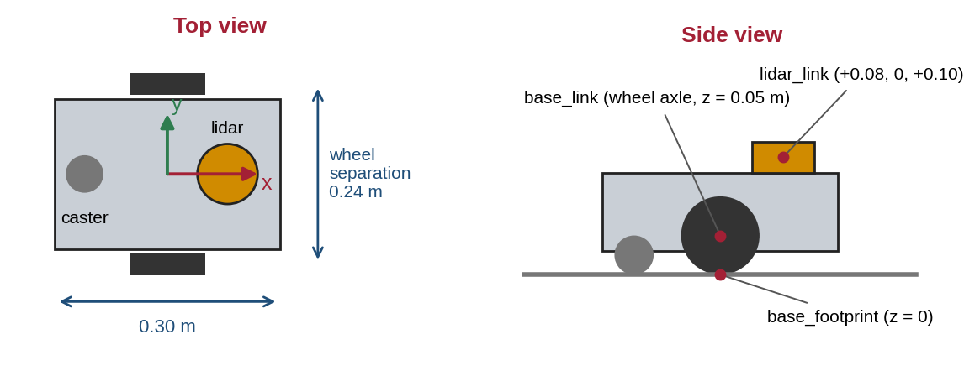
Figure 5.1: The my_bot mobile robot: top view with dimensions and side view with its main frames.

5.4 Mass and Inertia
Gazebo needs a realistic moment of inertia for each link; wrong values make robots jitter, sink or fly away. For simple shapes of mass m:
Shape | Ixx | Iyy | Izz
Box (size x, y, z) | m(y² + z²)/12 | m(x² + z²)/12 | m(x² + y²)/12
Cylinder (radius r, length h, along z) | m(3r² + h²)/12 | m(3r² + h²)/12 | m r²/2
Sphere (radius r) | 2 m r²/5 | 2 m r²/5 | 2 m r²/5

Worked example 5.1. Chassis box 0.30 × 0.20 × 0.10 m, m = 2.0 kg: Ixx = 2(0.04 + 0.01)/12 = 0.00833, Iyy = 2(0.09 + 0.01)/12 = 0.01667, Izz = 2(0.09 + 0.04)/12 = 0.02167 kg·m². Wheel cylinder r = 0.05 m, h = 0.03 m, m = 0.2 kg: Ixx = Iyy = 0.2(0.0075 + 0.0009)/12 = 0.00014, Izz = 0.2 × 0.0025/2 = 0.00025 kg·m². In the xacro file these formulas are written directly, so they update automatically if a size changes.

5.5 xacro: Smarter URDF Files
Plain URDF repeats a lot (two identical wheels, the same number in many places). xacro (XML macros) adds properties (named constants such as wheel_r), maths inside ${…} and macros (reusable blocks with parameters, such as one wheel macro used for both wheels). The xacro tool expands the file into plain URDF. The complete my_bot description, used in Lab 3, is shown there.

5.6 TF: Keeping Track of Frames
Every link has its own coordinate frame. The TF (tf2) library keeps track of how all frames relate over time, so any node can ask, for example, "where is the lidar relative to the odometry origin right now?" The robot_state_publisher node reads the URDF and the joint angles on /joint_states and broadcasts the transforms between the robot’s links. The transform from odom (where the robot started) to base_footprint comes from odometry — here from Gazebo’s DiffDrive system (Figure 5.2). On a real robot, a localisation system adds a map frame above odom.
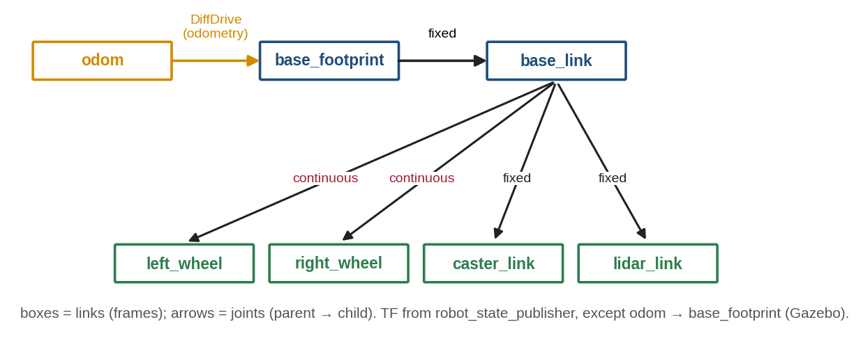
Figure 5.2: TF tree of my_bot: odometry frame, robot links and the joints that connect them.
Checking a description: xacro my_bot.urdf.xacro > /tmp/my_bot.urdf && check_urdf /tmp/my_bot.urdf prints the link tree or the first error. ros2 run tf2_tools view_frames saves a PDF of the live TF tree.

5.7 Common Mistakes to Avoid
- Units: URDF uses metres, kilograms and radians — a wheel radius of 5 (instead of 0.05) creates a 10 m wheel.
- Forgetting <inertial> or using zero mass on a moving link — Gazebo ignores or misbehaves with such links.
- Not rotating cylinder wheels (rpy = π/2 0 0): the wheel stands flat like a coin on a table.
- Two parents for one link, or a missing root — URDF must be a single tree.

6. Simulating a Mobile Robot in Gazebo

6.1 Why Simulate?
A simulator lets you test software before hardware exists, without risk of damage, and repeat the same test many times. Gazebo (formerly Ignition; command gz sim) is the official simulator of the ROS community. It provides physics (gravity, friction, collisions), sensors (lidar, cameras, IMU, GPS) and a 3D view. The older Gazebo Classic reached end of life in January 2025 and should not be used for new projects.

6.2 Worlds, Models and Systems
Gazebo describes everything in SDF (Simulation Description Format). A world file contains lights, a ground plane, obstacles (models) and systems (plug-ins) such as Physics, Sensors and SceneBroadcaster. When the URDF is loaded, <gazebo> tags inside it add robot systems: the DiffDrive system turns velocity commands into wheel motion and publishes odometry; the JointStatePublisher reports wheel angles; and a gpu_lidar sensor produces laser scans. The world used here (obstacles.sdf) is a 6 × 6 m room with three obstacles.

6.3 Differential-Drive Kinematics
A differential-drive robot steers by turning its two wheels at different speeds (Figure 6.1). With wheel radius r, wheel separation W and wheel angular speeds ω_L and ω_R (rad/s):
v = r (ω_R + ω_L) ÷ 2, ω = r (ω_R − ω_L) ÷ W, R = v ÷ ω(6.1)
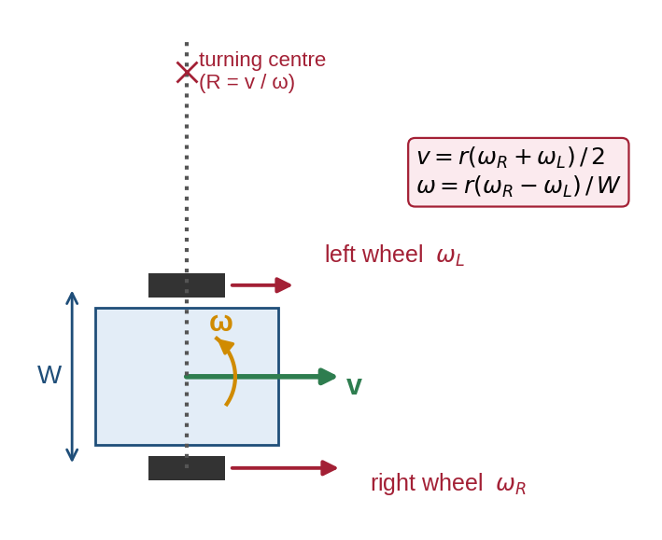
Figure 6.1: Differential drive: wheel speeds determine forward speed v, turning rate ω and turning radius R.
Worked example 6.1. r = 0.05 m, W = 0.24 m, ω_L = 4 rad/s, ω_R = 6 rad/s: v = 0.05 × 10 ÷ 2 = 0.25 m/s, ω = 0.05 × 2 ÷ 0.24 = 0.417 rad/s (anticlockwise), R = 0.25 ÷ 0.417 = 0.60 m. Worked example 6.2 (inverse). A /cmd_vel of v = 0.2 m/s, ω = 0.5 rad/s needs ω_R = (v + ωW/2) ÷ r = (0.2 + 0.06) ÷ 0.05 = 5.2 rad/s and ω_L = (0.2 − 0.06) ÷ 0.05 = 2.8 rad/s. This is exactly what the DiffDrive system calculates for every Twist message.

6.4 Connecting Gazebo and ROS 2: ros_gz_bridge
Gazebo has its own transport system, separate from ROS 2. The parameter_bridge node from ros_gz_bridge translates chosen topics in either direction (Figure 6.2). Each bridge argument has the form /topic@ros_type<symbol>gz_type, where the symbol gives the direction: `]` ROS → Gazebo, `[` Gazebo → ROS, `@` both ways. For example, /cmd_vel@geometry_msgs/msg/Twist]gz.msgs.Twist passes velocity commands into the simulation, and /scan@sensor_msgs/msg/LaserScan[gz.msgs.LaserScan brings laser scans out.
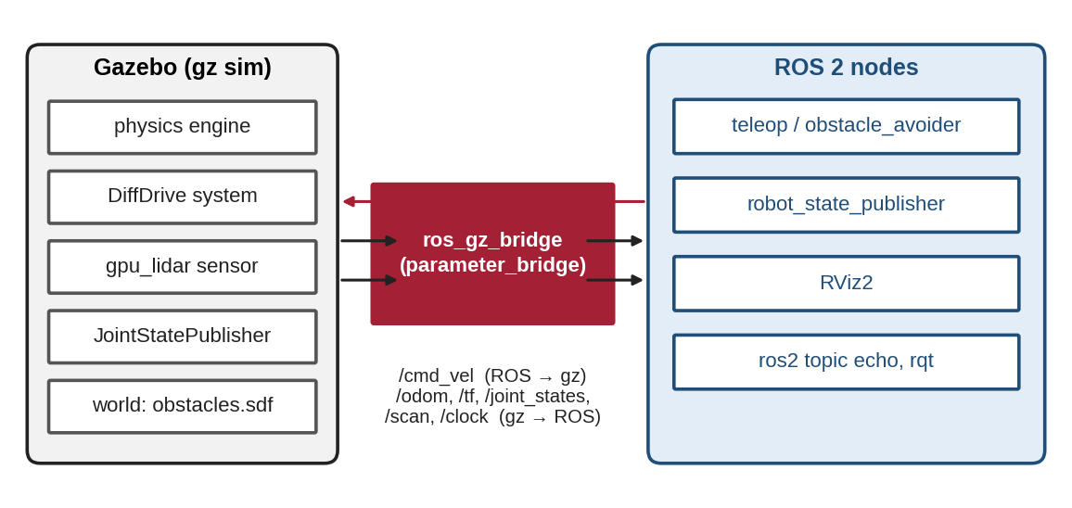
Figure 6.2: Gazebo and ROS 2 run separately; ros_gz_bridge translates the selected topics between them.

6.5 Launching the Simulation
The Lab 3 launch file does four things: starts Gazebo with the world (gz_sim.launch.py with -r to run immediately); runs robot_state_publisher with the expanded xacro; spawns the robot with ros_gz_sim create -topic robot_description; and starts the bridge. Because Gazebo publishes its own clock on /clock, all nodes that work with simulated data should use simulation time (use_sim_time:=true), otherwise their timestamps will not match and TF lookups will fail.
Once running, the robot can be driven with teleop_twist_keyboard, its data inspected with ros2 topic echo /odom, and everything viewed in RViz2 with the fixed frame set to odom, plus a RobotModel display (topic /robot_description), a LaserScan display (/scan) and a TF display.

6.6 Common Mistakes to Avoid
- Using Gazebo Classic plug-in names (libgazebo_ros_diff_drive.so) with new Gazebo — use gz-sim-diff-drive-system.
- Forgetting the Sensors system in the world file: the lidar produces no data.
- Bridge direction symbol wrong ([ vs ]), so commands never reach the robot.
- Mixing wall time and simulation time between nodes.

7. Practical Lab Exercises
The three labs take you from exploring an existing ROS system, to writing your own nodes, to describing and simulating a complete mobile robot. They need only a PC with ROS 2 Jazzy installed (Section 2.2). Each lab lists exact commands, the expected output and a model solution. Open several terminals; every new terminal must source ROS (and, after building, your workspace).
Lab | Title | Sections | Time
1 | Exploring ROS 2 with turtlesim and the ros2 CLI | 3, 4 | 2.5 h
2 | Publisher, subscriber, parameter and service in Python | 3, 4 | 3 h
3 | Describe and simulate a mobile robot in Gazebo | 5, 6 | 4 h

Lab Exercise 1: Exploring ROS 2 with turtlesim
Estimated time | Prerequisites
2.5 hours | Sections 3 and 4; ROS 2 Jazzy installed and sourced

Objective
To run a ready-made ROS 2 system and use the command-line and graphical tools to discover its nodes, topics, services, parameters and actions.
Hardware and Software Required
- PC with Ubuntu 24.04 and ROS 2 Jazzy desktop (turtlesim and rqt are included)
Working Principle
turtlesim is a tiny 2D simulator made for learning. Its node subscribes to velocity commands on /turtle1/cmd_vel, publishes the turtle’s pose on /turtle1/pose, offers services such as /spawn and /clear, has colour parameters and provides a rotate_absolute action — every communication method in one small program.
Procedure and Commands
- Terminal 1: ros2 run turtlesim turtlesim_node. Terminal 2: ros2 run turtlesim turtle_teleop_key and drive the turtle with the arrow keys.
- Terminal 3: list nodes and topics, inspect the velocity topic and its message type, and measure the pose rate.
- Run rqt_graph and compare the picture with Figure 4.1.
- Publish a command by hand, call the spawn service, change a parameter and send an action goal (commands below).
ros2 node list
ros2 topic list
ros2 topic info /turtle1/cmd_vel
ros2 interface show geometry_msgs/msg/Twist
ros2 topic hz /turtle1/pose
ros2 topic pub --once /turtle1/cmd_vel geometry_msgs/msg/Twist "{linear: {x: 2.0}, angular: {z: 1.8}}"
ros2 service call /spawn turtlesim/srv/Spawn "{x: 2.0, y: 2.0, theta: 0.2, name: 'turtle2'}"
ros2 param set /turtlesim background_r 150
ros2 action send_goal /turtle1/rotate_absolute turtlesim/action/RotateAbsolute "{theta: 1.57}" --feedback

Expected Output
$ ros2 node list $ ros2 topic info /turtle1/cmd_vel
/teleop_turtle Type: geometry_msgs/msg/Twist
/turtlesim Publisher count: 1
Subscription count: 1
$ ros2 topic list
/parameter_events $ ros2 service call /spawn ...
/rosout response:
/turtle1/cmd_vel turtlesim.srv.Spawn_Response(name='turtle2')
/turtle1/color_sensor
/turtle1/pose $ ros2 param set /turtlesim background_r 150
Set parameter successful

The topic pub command makes the turtle drive along an arc; the spawn call adds a second turtle at (2, 2); the background turns reddish; the action prints feedback (the remaining angle) and finishes with status SUCCEEDED. Exact numbers in feedback and timing may vary.
Observation
# | What to observe | Your observation
1 | Nodes, topics and the type of /turtle1/cmd_vel
2 | Average rate of /turtle1/pose
3 | Effect of each manual command (pub, spawn, param, action)
4 | Differences between rqt_graph and Figure 4.1

Model Solution
# | Correct result | Explanation
1 | /teleop_turtle, /turtlesim; 5 topics; geometry_msgs/msg/Twist | /parameter_events and /rosout exist in every ROS 2 system
2 | About 62 Hz | turtlesim updates its simulation about every 16 ms
3 | Arc motion; turtle2 appears; background changes; turtle turns to face up (1.57 rad) | Topic, service, parameter and action respectively
4 | Same two nodes joined by /turtle1/cmd_vel | rqt_graph hides /rosout and /parameter_events by default

Conclusion
The ros2 CLI and rqt make a running system transparent: you can see, test and even drive it without reading its code. Evidence to record: terminal screenshots, the rqt_graph image and completed tables.

Lab Exercise 2: Publisher, Subscriber, Parameter and Service in Python
Estimated time | Prerequisites
3 hours | Lab 1; basic Python classes

Objective
To create a ROS 2 Python package, write a publisher with a parameter, a subscriber and a service server, build them with colcon and test them with the CLI.
Working Principle
Each program is a class derived from Node. The talker creates a publisher on chatter and a 0.5 s timer whose callback publishes a String; its text comes from the greeting parameter. The listener’s subscription callback runs whenever a message arrives. The server answers AddTwoInts requests. rclpy.spin() keeps each node running and calls the callbacks.
Procedure
- Create the workspace and package: mkdir -p ~/ros2_ws/src && cd ~/ros2_ws/src, then ros2 pkg create --build-type ament_python --license Apache-2.0 my_first_pkg --dependencies rclpy std_msgs example_interfaces.
- Save talker.py, listener.py and add_server.py (below) in ~/ros2_ws/src/my_first_pkg/my_first_pkg/.
- Edit setup.py and replace the empty entry_points with the block shown below.
- Build: cd ~/ros2_ws && colcon build --symlink-install, then source install/setup.bash.
- Run ros2 run my_first_pkg talker and, in a second terminal, ros2 run my_first_pkg listener.
- While they run: ros2 topic hz /chatter, then ros2 param set /talker greeting "Namaste ROS" and watch the output change.
- Run ros2 run my_first_pkg add_server and call it: ros2 service call /add_two_ints example_interfaces/srv/AddTwoInts "{a: 2, b: 3}".
- Stop the talker; observe the listener. Start two listeners and observe that both receive every message.
Program Code
# my_first_pkg/my_first_pkg/talker.py - publishes a counter message twice per second
import rclpy
from rclpy.node import Node
from std_msgs.msg import String

class Talker(Node):
def __init__(self):
super().__init__('talker')
self.declare_parameter('greeting', 'Hello ROS 2') # can be changed at run time
self.pub = self.create_publisher(String, 'chatter', 10) # topic name, queue depth
self.count = 0
self.timer = self.create_timer(0.5, self.tick) # call tick() every 0.5 s

def tick(self):
msg = String()
greeting = self.get_parameter('greeting').value
msg.data = f'{greeting}: {self.count}'
self.pub.publish(msg)
self.get_logger().info(f'Publishing: "{msg.data}"')
self.count += 1

def main():
rclpy.init()
node = Talker()
try:
rclpy.spin(node) # keep the node alive and run callbacks
except KeyboardInterrupt:
pass
node.destroy_node()
rclpy.try_shutdown()

if __name__ == '__main__':
main()

# my_first_pkg/my_first_pkg/listener.py - prints every message received on /chatter
import rclpy
from rclpy.node import Node
from std_msgs.msg import String

class Listener(Node):
def __init__(self):
super().__init__('listener')
self.sub = self.create_subscription(String, 'chatter', self.on_msg, 10)

def on_msg(self, msg):
self.get_logger().info(f'I heard: "{msg.data}"')

def main():
rclpy.init()
node = Listener()
try:
rclpy.spin(node)
except KeyboardInterrupt:
pass
node.destroy_node()
rclpy.try_shutdown()

if __name__ == '__main__':
main()

# my_first_pkg/my_first_pkg/add_server.py - a service that adds two integers
import rclpy
from rclpy.node import Node
from example_interfaces.srv import AddTwoInts

class AddServer(Node):
def __init__(self):
super().__init__('add_server')
self.srv = self.create_service(AddTwoInts, 'add_two_ints', self.handle)

def handle(self, request, response):
response.sum = request.a + request.b
self.get_logger().info(f'{request.a} + {request.b} = {response.sum}')
return response

def main():
rclpy.init()
node = AddServer()
try:
rclpy.spin(node)
except KeyboardInterrupt:
pass
node.destroy_node()
rclpy.try_shutdown()

if __name__ == '__main__':
main()

# in my_first_pkg/setup.py - replace the empty entry_points with:
entry_points={
'console_scripts': [
'talker = my_first_pkg.talker:main',
'listener = my_first_pkg.listener:main',
'add_server = my_first_pkg.add_server:main',
],
},

Expected Output
[INFO] [1760000000.512345678] [talker]: Publishing: "Hello ROS 2: 0"
[INFO] [1760000001.012345678] [talker]: Publishing: "Hello ROS 2: 1"
[INFO] [1760000001.013456789] [listener]: I heard: "Hello ROS 2: 1"
$ ros2 service call /add_two_ints example_interfaces/srv/AddTwoInts "{a: 2, b: 3}"
response:
example_interfaces.srv.AddTwoInts_Response(sum=5)

Timestamps differ on every run. The listener may miss the first message if it starts after the talker — this is normal for VOLATILE topics.
Observation
# | What to observe | Your observation
1 | Rate reported by ros2 topic hz /chatter
2 | Output after changing the greeting parameter
3 | Service response for a = 2, b = 3 and for your own numbers
4 | Listener behaviour when the talker stops
5 | Behaviour with two listeners

Model Solution
# | Correct result | Explanation
1 | ≈ 2.000 Hz | Timer period 0.5 s
2 | "Namaste ROS: n" from the next message onward | The parameter is read inside every timer callback
3 | sum=5 (and a + b for any integers) | Server fills response.sum and returns it
4 | Listener keeps running but prints nothing | Subscribers do not depend on any particular publisher
5 | Both print every message | Topics are many-to-many

Conclusion
A ROS 2 node is a small Python class; packages, entry points and colcon turn it into a reusable command. Evidence to record: package tree, code, terminal output and completed tables.

Lab Exercise 3: Describe and Simulate a Mobile Robot in Gazebo
Estimated time | Prerequisites
4 hours | Sections 5 and 6; Lab 2; ros-jazzy-ros-gz and ros-jazzy-xacro installed

Objective
To write the URDF/xacro description of my_bot, check it, spawn it in a Gazebo world with obstacles, connect it to ROS 2 with ros_gz_bridge, drive it with the keyboard and view the robot, TF and laser scan in RViz.
Procedure
- Create the package: cd ~/ros2_ws/src && ros2 pkg create --build-type ament_python --license Apache-2.0 my_bot --dependencies rclpy geometry_msgs sensor_msgs, then mkdir -p my_bot/launch my_bot/urdf my_bot/worlds.
- Save my_bot.urdf.xacro in urdf/, obstacles.sdf in worlds/ and sim.launch.py in launch/. Replace setup.py with the version below. In package.xml add <exec_depend> lines for robot_state_publisher, ros_gz_sim, ros_gz_bridge and xacro.
- Check the description: xacro my_bot/urdf/my_bot.urdf.xacro > /tmp/my_bot.urdf && check_urdf /tmp/my_bot.urdf.
- Build and source: cd ~/ros2_ws && colcon build --symlink-install && source install/setup.bash.
- Launch: ros2 launch my_bot sim.launch.py. Gazebo opens with the robot in the room.
- Drive: ros2 run teleop_twist_keyboard teleop_twist_keyboard (keys i, j, l, k). Watch ros2 topic echo /odom --field pose.pose.position.
- Visualise: rviz2 --ros-args -p use_sim_time:=true; fixed frame odom; add RobotModel (topic /robot_description), TF and LaserScan (/scan).
- Publish ros2 topic pub --once /cmd_vel geometry_msgs/msg/Twist "{linear: {x: 0.2}, angular: {z: 0.5}}" and estimate the circle radius from /odom.
Program Code
Robot description (urdf/my_bot.urdf.xacro):
<?xml version="1.0"?>
<!-- my_bot: differential-drive robot with a 2D lidar (Lab 3 and mini-project) -->
<robot name="my_bot" xmlns:xacro="http://www.ros.org/wiki/xacro">
<xacro:property name="base_l" value="0.30"/> <xacro:property name="base_w" value="0.20"/>
<xacro:property name="base_h" value="0.10"/> <xacro:property name="base_m" value="2.0"/>
<xacro:property name="wheel_r" value="0.05"/> <xacro:property name="wheel_w" value="0.03"/>
<xacro:property name="wheel_m" value="0.2"/> <xacro:property name="wheel_y" value="0.12"/>

<!-- base_footprint lies on the ground under the robot centre -->
<link name="base_footprint"/>
<joint name="base_joint" type="fixed">
<parent link="base_footprint"/> <child link="base_link"/>
<origin xyz="0 0 ${wheel_r}"/>
</joint>

<link name="base_link">
<visual>
<origin xyz="0 0 0.03"/> <geometry><box size="${base_l} ${base_w} ${base_h}"/></geometry>
</visual>
<collision>
<origin xyz="0 0 0.03"/> <geometry><box size="${base_l} ${base_w} ${base_h}"/></geometry>
</collision>
<inertial>
<origin xyz="0 0 0.03"/> <mass value="${base_m}"/>
<inertia ixx="${base_m*(base_w**2+base_h**2)/12}" iyy="${base_m*(base_l**2+base_h**2)/12}"
izz="${base_m*(base_l**2+base_w**2)/12}" ixy="0" ixz="0" iyz="0"/>
</inertial>
</link>

<!-- one macro builds both wheels; reflect = +1 (left) or -1 (right) -->
<xacro:macro name="wheel" params="side reflect">
<link name="${side}_wheel">
<visual>
<origin rpy="${pi/2} 0 0"/> <geometry><cylinder radius="${wheel_r}" length="${wheel_w}"/></geometry>
</visual>
<collision>
<origin rpy="${pi/2} 0 0"/> <geometry><cylinder radius="${wheel_r}" length="${wheel_w}"/></geometry>
</collision>
<inertial>
<origin rpy="${pi/2} 0 0"/> <mass value="${wheel_m}"/>
<inertia ixx="${wheel_m*(3*wheel_r**2+wheel_w**2)/12}" iyy="${wheel_m*(3*wheel_r**2+wheel_w**2)/12}"
izz="${wheel_m*wheel_r**2/2}" ixy="0" ixz="0" iyz="0"/>
</inertial>
</link>
<joint name="${side}_wheel_joint" type="continuous">
<parent link="base_link"/> <child link="${side}_wheel"/>
<origin xyz="0 ${reflect*wheel_y} 0"/> <axis xyz="0 1 0"/>
</joint>
</xacro:macro>
<xacro:wheel side="left" reflect="1"/>
<xacro:wheel side="right" reflect="-1"/>

<!-- frictionless caster ball at the back -->
<link name="caster_link">
<visual><geometry><sphere radius="0.025"/></geometry></visual>
<collision><geometry><sphere radius="0.025"/></geometry></collision>
<inertial><mass value="0.05"/>
<inertia ixx="1.25e-5" iyy="1.25e-5" izz="1.25e-5" ixy="0" ixz="0" iyz="0"/></inertial>
</link>
<joint name="caster_joint" type="fixed">
<parent link="base_link"/> <child link="caster_link"/> <origin xyz="-0.11 0 -0.025"/>
</joint>
<gazebo reference="caster_link"> <mu1>0.0</mu1> <mu2>0.0</mu2> </gazebo>

<!-- 2D lidar on top of the chassis -->
<link name="lidar_link">
<visual><geometry><cylinder radius="0.04" length="0.04"/></geometry></visual>
<collision><geometry><cylinder radius="0.04" length="0.04"/></geometry></collision>
<inertial><mass value="0.1"/>
<inertia ixx="5.33e-5" iyy="5.33e-5" izz="8.0e-5" ixy="0" ixz="0" iyz="0"/></inertial>
</link>
<joint name="lidar_joint" type="fixed">
<parent link="base_link"/> <child link="lidar_link"/> <origin xyz="0.08 0 0.10"/>
</joint>

<!-- Gazebo (Harmonic) systems: differential drive and joint states -->
<gazebo>
<plugin filename="gz-sim-diff-drive-system" name="gz::sim::systems::DiffDrive">
<left_joint>left_wheel_joint</left_joint> <right_joint>right_wheel_joint</right_joint>
<wheel_separation>${2*wheel_y}</wheel_separation> <wheel_radius>${wheel_r}</wheel_radius>
<topic>/cmd_vel</topic> <odom_topic>/odom</odom_topic> <tf_topic>/tf</tf_topic>
<frame_id>odom</frame_id> <child_frame_id>base_footprint</child_frame_id>
<odom_publish_frequency>30</odom_publish_frequency>
</plugin>
<plugin filename="gz-sim-joint-state-publisher-system" name="gz::sim::systems::JointStatePublisher">
<topic>/joint_states</topic>
</plugin>
</gazebo>
<gazebo reference="lidar_link">
<sensor name="lidar" type="gpu_lidar">
<topic>/scan</topic> <gz_frame_id>lidar_link</gz_frame_id>
<update_rate>10</update_rate> <always_on>true</always_on> <visualize>true</visualize>
<lidar>
<scan><horizontal><samples>360</samples><resolution>1</resolution>
<min_angle>-3.14159</min_angle><max_angle>3.14159</max_angle></horizontal></scan>
<range><min>0.12</min><max>8.0</max><resolution>0.01</resolution></range>
</lidar>
</sensor>
</gazebo>
</robot>

World (worlds/obstacles.sdf) — the room walls repeat the same pattern with different names, poses and sizes:
<?xml version="1.0"?>
<sdf version="1.9">
<world name="obstacles">
<plugin filename="gz-sim-physics-system" name="gz::sim::systems::Physics"/>
<plugin filename="gz-sim-user-commands-system" name="gz::sim::systems::UserCommands"/>
<plugin filename="gz-sim-scene-broadcaster-system" name="gz::sim::systems::SceneBroadcaster"/>
<plugin filename="gz-sim-sensors-system" name="gz::sim::systems::Sensors">
<render_engine>ogre2</render_engine>
</plugin>
<light type="directional" name="sun">
<pose>0 0 10 0 0 0</pose> <direction>-0.5 0.1 -0.9</direction>
</light>
<model name="ground_plane"> <static>true</static>
<link name="link">
<collision name="c"><geometry><plane><normal>0 0 1</normal><size>20 20</size></plane></geometry></collision>
<visual name="v"><geometry><plane><normal>0 0 1</normal><size>20 20</size></plane></geometry></visual>
</link>
</model>
<model name="box_1"> <static>true</static> <pose>2.0 0.0 0.25 0 0 0</pose>
<link name="link">
<collision name="c"><geometry><box><size>0.5 1.0 0.5</size></box></geometry></collision>
<visual name="v"><geometry><box><size>0.5 1.0 0.5</size></box></geometry></visual>
</link>
</model>
<model name="box_2"> <static>true</static> <pose>0.5 2.0 0.25 0 0 0.6</pose>
<link name="link">
<collision name="c"><geometry><box><size>1.0 0.4 0.5</size></box></geometry></collision>
<visual name="v"><geometry><box><size>1.0 0.4 0.5</size></box></geometry></visual>
</link>
</model>
<model name="divider"> <static>true</static> <pose>-1.5 -0.5 0.25 0 0 0</pose>
<link name="link">
<collision name="c"><geometry><box><size>0.2 3.0 0.5</size></box></geometry></collision>
<visual name="v"><geometry><box><size>0.2 3.0 0.5</size></box></geometry></visual>
</link>
</model>
<model name="wall_n"> <static>true</static> <pose>0 3.1 0.25 0 0 0</pose>
<link name="link">
<collision name="c"><geometry><box><size>6.4 0.2 0.5</size></box></geometry></collision>
<visual name="v"><geometry><box><size>6.4 0.2 0.5</size></box></geometry></visual>
</link>
</model>
<model name="wall_s"> <static>true</static> <pose>0 -3.1 0.25 0 0 0</pose>
<link name="link">
<collision name="c"><geometry><box><size>6.4 0.2 0.5</size></box></geometry></collision>
<visual name="v"><geometry><box><size>6.4 0.2 0.5</size></box></geometry></visual>
</link>
</model>
<model name="wall_e"> <static>true</static> <pose>3.1 0 0.25 0 0 0</pose>
<link name="link">
<collision name="c"><geometry><box><size>0.2 6.0 0.5</size></box></geometry></collision>
<visual name="v"><geometry><box><size>0.2 6.0 0.5</size></box></geometry></visual>
</link>
</model>
<model name="wall_w"> <static>true</static> <pose>-3.1 0 0.25 0 0 0</pose>
<link name="link">
<collision name="c"><geometry><box><size>0.2 6.0 0.5</size></box></geometry></collision>
<visual name="v"><geometry><box><size>0.2 6.0 0.5</size></box></geometry></visual>
</link>
</model>
</world>
</sdf>

Launch file (launch/sim.launch.py) and setup.py:
# my_bot/launch/sim.launch.py - Gazebo world + robot + ROS-Gazebo bridge
import os
import xacro
from ament_index_python.packages import get_package_share_directory
from launch import LaunchDescription
from launch.actions import IncludeLaunchDescription
from launch.launch_description_sources import PythonLaunchDescriptionSource
from launch_ros.actions import Node

def generate_launch_description():
pkg = get_package_share_directory('my_bot')
robot_xml = xacro.process_file(os.path.join(pkg, 'urdf', 'my_bot.urdf.xacro')).toxml()
world = os.path.join(pkg, 'worlds', 'obstacles.sdf')

gazebo = IncludeLaunchDescription( # start Gazebo with our world, running (-r)
PythonLaunchDescriptionSource(os.path.join(
get_package_share_directory('ros_gz_sim'), 'launch', 'gz_sim.launch.py')),
launch_arguments={'gz_args': f'-r {world}'}.items())

state_pub = Node( # publishes /robot_description and TF
package='robot_state_publisher', executable='robot_state_publisher',
parameters=[{'robot_description': robot_xml, 'use_sim_time': True}])

spawn = Node( # insert the robot into the running world
package='ros_gz_sim', executable='create',
arguments=['-topic', 'robot_description', '-name', 'my_bot', '-z', '0.02'])

bridge = Node( # connect Gazebo topics to ROS 2 topics
package='ros_gz_bridge', executable='parameter_bridge',
arguments=['/cmd_vel@geometry_msgs/msg/Twist]gz.msgs.Twist',
'/odom@nav_msgs/msg/Odometry[gz.msgs.Odometry',
'/scan@sensor_msgs/msg/LaserScan[gz.msgs.LaserScan',
'/tf@tf2_msgs/msg/TFMessage[gz.msgs.Pose_V',
'/joint_states@sensor_msgs/msg/JointState[gz.msgs.Model',
'/clock@rosgraph_msgs/msg/Clock[gz.msgs.Clock'])

return LaunchDescription([gazebo, state_pub, spawn, bridge])

# my_bot/setup.py - install launch, urdf and world files so ROS can find them
import os
from glob import glob
from setuptools import find_packages, setup

package_name = 'my_bot'

setup(
name=package_name,
version='0.1.0',
packages=find_packages(exclude=['test']),
data_files=[
('share/ament_index/resource_index/packages', ['resource/' + package_name]),
('share/' + package_name, ['package.xml']),
(os.path.join('share', package_name, 'launch'), glob('launch/*.launch.py')),
(os.path.join('share', package_name, 'urdf'), glob('urdf/*')),
(os.path.join('share', package_name, 'worlds'), glob('worlds/*')),
],
install_requires=['setuptools'],
zip_safe=True,
maintainer='student',
maintainer_email='student@example.com',
description='Differential-drive robot for Gazebo',
license='Apache-2.0',
entry_points={
'console_scripts': ['obstacle_avoider = my_bot.obstacle_avoider:main'],
},
)

Expected Output
$ check_urdf /tmp/my_bot.urdf
robot name is: my_bot
---------- Successfully Parsed XML ---------------
root Link: base_footprint has 1 child(ren)
child(1): base_link
child(1): left_wheel (the order of these four children may differ)
child(2): right_wheel
child(3): caster_link
child(4): lidar_link

Gazebo shows the robot in a walled room with three obstacles and visible lidar rays; RViz shows the model, TF frames and scan points outlining walls and boxes.
Observation
# | What to observe | Your observation
1 | check_urdf output (root link and number of links)
2 | Topics listed after launch (ros2 topic list)
3 | Rate of /scan and of /odom (ros2 topic hz)
4 | Circle radius for v = 0.2 m/s, ω = 0.5 rad/s
5 | Screenshot of RViz with model, TF and scan

Model Solution
# | Correct result | Explanation
1 | Root base_footprint; 6 links | base_footprint, base_link, 2 wheels, caster, lidar (verified with the xacro and URDF parser tools)
2 | Includes /cmd_vel, /odom, /scan, /tf, /joint_states, /clock, /robot_description | Bridged topics plus robot_state_publisher outputs
3 | /scan ≈ 10 Hz; /odom ≈ 30 Hz | update_rate 10 and odom_publish_frequency 30 in the URDF
4 | R = v ÷ ω = 0.4 m (circle diameter ≈ 0.8 m) | Equation (6.1); wheels at 5.2 and 2.8 rad/s
5 | Scan points line up with walls and boxes | Lidar frame and TF are consistent

Conclusion
A single xacro file describes the robot for RViz, TF and Gazebo, and the bridge makes the simulated robot look like a real ROS 2 robot to every other node. Evidence to record: check_urdf output, Gazebo and RViz screenshots, odometry readings and completed tables.

8. Integrated Mini-Project: Autonomous Obstacle-Avoiding Robot

8.1 Problem Statement and Design
Make my_bot explore the room by itself without touching anything. Write a node obstacle_avoider that subscribes to /scan, divides the scan into three sectors and publishes /cmd_vel (Figure 8.1): if the front sector is clear beyond 0.6 m, drive forward at 0.2 m/s; otherwise turn on the spot towards the more open side. The decision logic is a separate pure function decide(), so it can be tested without ROS.
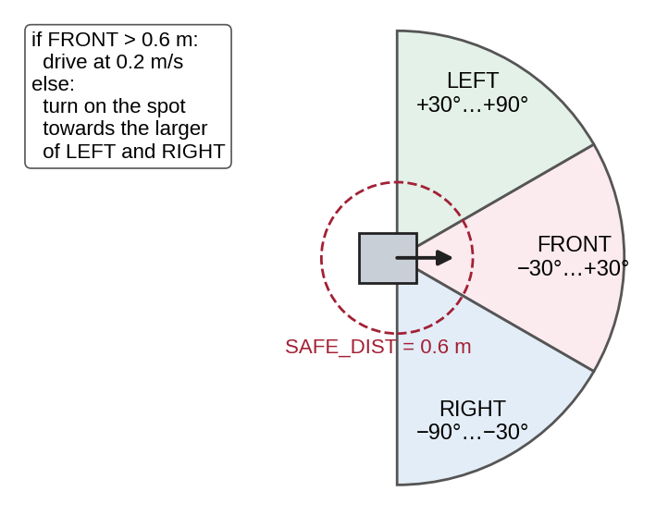
Figure 8.1: Lidar sectors and decision rule of the obstacle_avoider node.

8.2 Code and Workflow
Save the node as ~/ros2_ws/src/my_bot/my_bot/obstacle_avoider.py (its entry point is already in setup.py), rebuild, start the simulation with ros2 launch my_bot sim.launch.py and, in a second terminal, run ros2 run my_bot obstacle_avoider --ros-args -p use_sim_time:=true.
# my_bot/my_bot/obstacle_avoider.py - drive forward, turn away from obstacles seen by the lidar
import math
import rclpy
from rclpy.node import Node
from geometry_msgs.msg import Twist
from sensor_msgs.msg import LaserScan

SAFE_DIST = 0.6 # m: closer than this in front -> turn
FRONT = math.radians(30)
SIDE = math.radians(90)

def sector_min(ranges, angle_min, inc, lo, hi):
"""Smallest valid range for beams with lo <= angle < hi (radians)."""
vals = [r for i, r in enumerate(ranges)
if lo <= angle_min + i * inc < hi and math.isfinite(r) and r > 0.0]
return min(vals) if vals else float('inf')

def decide(ranges, angle_min, inc):
"""Return (linear m/s, angular rad/s) from one scan. Pure function: easy to test."""
front = sector_min(ranges, angle_min, inc, -FRONT, FRONT)
left = sector_min(ranges, angle_min, inc, FRONT, SIDE)
right = sector_min(ranges, angle_min, inc, -SIDE, -FRONT)
if front > SAFE_DIST:
return 0.2, 0.0 # path clear: go straight
return 0.0, (0.6 if left > right else -0.6) # turn towards the more open side

class ObstacleAvoider(Node):
def __init__(self):
super().__init__('obstacle_avoider')
self.pub = self.create_publisher(Twist, '/cmd_vel', 10)
self.create_subscription(LaserScan, '/scan', self.on_scan, 10)

def on_scan(self, scan):
v, w = decide(scan.ranges, scan.angle_min, scan.angle_increment)
cmd = Twist()
cmd.linear.x, cmd.angular.z = v, w
self.pub.publish(cmd)

def main():
rclpy.init()
node = ObstacleAvoider()
try:
rclpy.spin(node)
except KeyboardInterrupt:
pass
node.pub.publish(Twist()) # stop the robot on exit
node.destroy_node()
rclpy.try_shutdown()

if __name__ == '__main__':
main()

Before running it in Gazebo, the decide() logic was tested with synthetic scans and with a simple 2D Python model of the same room (Figure 8.2): the robot explored for 120 s and its lidar never came closer than 0.30 m to an obstacle. This preview uses ideal sensors and no physics, so results in Gazebo will differ slightly.
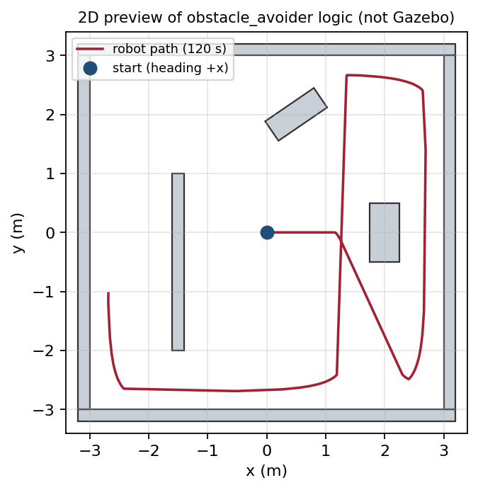
Figure 8.2: 2D Python preview of the avoidance logic in the obstacles.sdf layout (not a Gazebo result).

8.3 Test Cases
Test | Action | Expected result
TC1 | Unit test: scan with all ranges = inf | decide() returns (0.2, 0.0) — drive straight
TC2 | Unit test: front 0.4 m, left 3.0 m, right 1.0 m | (0.0, +0.6) — turn left
TC3 | Unit test: front 0.4 m, left 1.0 m, right 3.0 m | (0.0, −0.6) — turn right
TC4 | Gazebo: run for 5 minutes | No collisions; robot keeps moving
TC5 | Ctrl + C the node | Robot stops (zero Twist published on exit)
TC6 | Move an obstacle in Gazebo in front of the robot | Robot turns away within about 0.2 s

Limitations: purely reactive — no map, no goal, can wander in loops or get stuck in a narrow corner; it ignores the robot’s width when choosing a side. Extensions: slow down proportionally as obstacles get closer; add a parameter for SAFE_DIST; record a bag and plot the path from /odom; add a camera sensor; or replace the reactive logic with Nav2 and SLAM to build a map and navigate to goals.

9. Troubleshooting and Common Mistakes
Problem | Likely cause | Fix
ros2: command not found | ROS not sourced | source /opt/ros/jazzy/setup.bash (add to ~/.bashrc)
Package 'my_bot' not found | Workspace not built or not sourced | colcon build, then source install/setup.bash
No executable found | Entry point missing in setup.py | Add it to console_scripts and rebuild
Nodes cannot see each other | Different ROS_DOMAIN_ID or firewall | Use the same ID; check ros2 doctor
Subscriber receives nothing | Wrong topic name/type or QoS mismatch | ros2 topic info -v <topic>
Gazebo window black or crashes (VM/WSL) | No GPU acceleration | export LIBGL_ALWAYS_SOFTWARE=1 before launching
Robot does not move | Bridge direction wrong or wrong topic | Use ]gz.msgs.Twist for /cmd_vel; check gz topic -l
No /scan data | Sensors system missing in world | Add gz-sim-sensors-system to the world
RViz: no transform / robot white | Wrong fixed frame or time mismatch | Fixed frame odom; use_sim_time:=true everywhere
Robot jitters or sinks | Bad inertia or mass | Use the formulas of Section 5.4

10. Assessment and Revision

10.1 Formula and Command Sheet
Item | Formula / command
Differential drive (forward) | v = r(ω_R + ω_L)/2; ω = r(ω_R − ω_L)/W; R = v/ω
Differential drive (inverse) | ω_R = (v + ωW/2)/r; ω_L = (v − ωW/2)/r
Box / cylinder inertia | Ixx = m(y² + z²)/12; cylinder Izz = m r²/2, Ixx = m(3r² + h²)/12
Data rate | bytes per message × messages per second
Build and source | colcon build --symlink-install; source install/setup.bash
Inspect | ros2 node|topic|service|action|param list; ros2 topic info -v; rqt_graph
Bridge syntax | /topic@ros_type]gz_type (ROS→gz), [ (gz→ROS), @ (both)

10.2 Short Conceptual Questions
- Why is ROS described as middleware rather than an operating system?
- Give three advantages of ROS 2 over ROS 1.
- What is an LTS distribution, and why is it preferred for teaching and products?
- Explain the difference between a package and a workspace, and between an underlay and an overlay.
- When would you use a topic, a service and an action? Give one example of each.
- What happens when a RELIABLE subscriber connects to a BEST_EFFORT publisher?
- What are the three parts of a URDF link, and why does Gazebo need the inertial part?
- What does ros_gz_bridge do, and why is use_sim_time needed in simulation?
Answer key (brief): 1 — it runs on an OS and provides communication, tools and packages. 2 — no master, DDS QoS, security/real-time/multi-OS. 3 — 5-year support; stable target. 4 — package = one unit of code; workspace = folder of packages; underlay = ROS install, overlay = your built workspace. 5 — sensor stream; spawn/reset; navigate to a goal. 6 — they do not connect; no data arrives. 7 — visual, collision, inertial; physics needs mass and inertia. 8 — translates Gazebo and ROS topics; Gazebo’s clock differs from wall time.

10.3 Numerical Problems with Worked Solutions
Problem 1. r = 0.05 m, W = 0.24 m, ω_L = ω_R = 8 rad/s. Solution: v = 0.05 × 16 ÷ 2 = 0.4 m/s, ω = 0 (straight line).
Problem 2. Same robot, ω_L = −3 rad/s, ω_R = 3 rad/s. Solution: v = 0, ω = 0.05 × 6 ÷ 0.24 = 1.25 rad/s: it spins on the spot, one full turn in 2π ÷ 1.25 ≈ 5.0 s.
Problem 3. Required wheel speeds for v = 0.3 m/s, ω = −1.0 rad/s? Solution: ωW/2 = −0.12; ω_R = (0.3 − 0.12) ÷ 0.05 = 3.6 rad/s; ω_L = (0.3 + 0.12) ÷ 0.05 = 8.4 rad/s (turns right).
Problem 4. A 1080-sample lidar (ranges and intensities, 4 bytes each) at 20 Hz. Solution: 2 × 1080 × 4 × 20 = 172,800 B/s ≈ 173 kB/s.
Problem 5. Inertia of a 0.5 kg cylinder of radius 0.04 m and length 0.06 m about its axis and across it. Solution: Izz = 0.5 × 0.0016 ÷ 2 = 0.0004 kg·m²; Ixx = 0.5(0.0048 + 0.0036) ÷ 12 = 0.00035 kg·m².

10.4 Practical Checklist and Rubric
# | The learner can… | Done
1 | Install and source ROS 2; use ROS_DOMAIN_ID correctly | ☐
2 | Inspect a running system with the ros2 CLI and rqt_graph (Lab 1) | ☐
3 | Write, build and run publisher, subscriber, parameter and service nodes (Lab 2) | ☐
4 | Write and check a URDF/xacro with correct inertia and TF (Lab 3) | ☐
5 | Simulate, drive and visualise the robot in Gazebo and RViz (Lab 3) | ☐
6 | Run the obstacle-avoiding robot and pass TC1–TC6 (mini-project) | ☐

Criterion (4 marks each) | Excellent (4) | Good (3–2) | Needs work (1–0)
Concepts and architecture | Clear, correct, with examples | Minor gaps | Confuses ROS 1/2 or terms
Communication | Correct method and QoS chosen | Works with small issues | Wrong method or not working
Robot description | Valid URDF, correct units/inertia/TF | One error | Invalid or unrealistic
Simulation | Robot driven and visualised correctly | Partly working | Not running
Mini-project and report | All tests pass, evidence complete | Some tests or evidence missing | Not completed

Glossary
Term | Meaning in simple words
Action | Long-running task with goal, feedback and result; can be cancelled.
ament | ROS 2 build system types: ament_python and ament_cmake.
Callback | Function that ROS runs when an event happens (message, timer, request).
colcon | Command-line tool that builds all packages in a workspace.
DDS | Data Distribution Service: industrial publish/subscribe standard used by ROS 2.
Differential drive | Two independently driven wheels that steer by speed difference.
Distribution (distro) | Versioned, tested set of ROS packages, e.g. Jazzy.
Gazebo | Physics-based robot simulator (gz sim).
Interface | Typed definition of messages (.msg), services (.srv) or actions (.action).
Launch file | Script that starts several nodes with their settings.
LTS | Long-term support: maintained for five years.
Middleware | Software layer that connects programs and handles communication.
Node | One running ROS program with a single job.
Odometry | Estimate of robot motion from wheel rotation.
Overlay / underlay | Your workspace built on top of the ROS installation.
Package | Unit of ROS code with a package.xml manifest.
Parameter | Named setting of a node, changeable at run time.
Publisher / subscriber | Node side that sends / receives messages on a topic.
QoS | Quality of service: rules for delivery (reliability, durability, history).
rclpy / rclcpp | ROS 2 client libraries for Python / C++.
rmw | ROS middleware interface hiding the DDS implementation.
robot_state_publisher | Node that publishes the URDF and TF of the robot links.
ros_gz_bridge | Package translating topics between Gazebo and ROS 2.
ROS_DOMAIN_ID | Number that separates groups of ROS nodes on one network.
RViz2 | 3D visualisation tool for robot data.
SDF | Simulation Description Format used by Gazebo for worlds and models.
Service | Request/response communication between a client and a server.
Simulation time | Clock published by the simulator on /clock.
TF (tf2) | Library tracking coordinate frames and transforms over time.
Topic | Named channel for streaming messages.
URDF | XML description of a robot’s links and joints.
Workspace | Folder with a src directory of packages, built by colcon.
xacro | XML macro language that generates URDF.

References
ROS evolves quickly. The official documentation and REPs listed here are the authoritative sources and should be checked for the latest versions and installation steps.
[1]Quigley, M., Conley, K., Gerkey, B., et al. (2009). ROS: an open-source Robot Operating System. ICRA Workshop on Open Source Software.
[2]Macenski, S., Foote, T., Gerkey, B., Lalancette, C., & Woodall, W. (2022). Robot Operating System 2: Design, architecture, and uses in the wild. Science Robotics, 7(66), eabm6074.
[3]Koubaa, A. (Ed.). Robot Operating System (ROS): The Complete Reference (multiple volumes). Springer.
[4]Joseph, L., & Cacace, J. (2021). Mastering ROS for Robotics Programming (3rd ed.). Packt.
[5]ROS 2 Documentation (Jazzy). https://docs.ros.org/en/jazzy/
[6]ROS 2 Releases and distributions. https://docs.ros.org/en/rolling/Releases.html
[7]REP 2000: ROS 2 Releases and Target Platforms. https://www.ros.org/reps/rep-2000.html
[8]REP 103: Standard Units of Measure and Coordinate Conventions. https://www.ros.org/reps/rep-0103.html
[9]REP 105: Coordinate Frames for Mobile Platforms. https://www.ros.org/reps/rep-0105.html
[10]URDF XML specification. http://wiki.ros.org/urdf/XML
[11]xacro repository and documentation. https://github.com/ros/xacro
[12]Gazebo documentation (Harmonic). https://gazebosim.org/docs/harmonic/
[13]ros_gz (ROS 2–Gazebo integration). https://github.com/gazebosim/ros_gz
[14]Nav2 documentation. https://docs.nav2.org/
[15]Open Robotics. https://www.openrobotics.org/

